B.1 User Story Test Cases:
Test ID | Input Variables | Test Condition | Test Data / Values | Expected Result
US-01 | Subject, Description, Points, Assigned To, Milestone, Status | Base valid input | Subject: "New Login Feature"; Description provided; Points: 5; Valid assigned user; Valid milestone | User story is created successfully
US-02 | Subject | Empty/invalid subject | Subject: empty or whitespace only | System rejects user story creation
US-03 | Assigned To, Assigned Users | Invalid user assignment | Assigned user does not belong to project | System rejects invalid assignment
US-04 | Points, Status, Is Blocked | Boundary/state validation | Invalid points value or blocked state without required information | System rejects invalid input combination

B.2 Task Test Cases:
Test ID | Input Variables | Test Condition | Test Data / Values | Expected Result
TK-01 | Subject, Description, User Story, Assigned To, Due Date | Base valid input | Valid subject; description; linked user story; assigned user; future due date | Task is created successfully
TK-02 | Subject | Empty/invalid subject | Subject: empty or whitespace only | System rejects task creation
TK-03 | Assigned To, User Story | Invalid relationship | The assigned user or user story does not exist | The system rejects an invalid relationship
TK-04 | Due Date, Is Blocked, Status | Boundary/state validation | Past due date or invalid blocked state | The system rejects invalid input

B3. Issue Test Cases:
Test ID | Input Variables | Test Condition | Test Data / Values | Expected Result
IS-01 | Subject, Description, Type, Severity, Priority, Assigned To | Base valid input | Valid subject; description; issue type; severity; priority; assigned user | Issue is created successfully
IS-02 | Subject | Empty subject | Subject: empty | System rejects issue creation
IS-03 | Type, Severity, Priority | Invalid issue classification | Invalid type/severity/priority value | System rejects invalid classification
IS-04 | Assigned To, Milestone, Status | Invalid relationship/state | Invalid assigned user or milestone state | System rejects invalid input

B.4 Sprit/Milestone Test Cases:
Test ID | Input Variables | Test Condition | Test Data / Values | Expected Result
SP-01 | Name, Estimated Start, Estimated Finish, Sprint State | Base valid input | Name: Sprint 1; Valid start date; Valid finish date; Valid sprint state | Sprint/Milestone is created successfully
SP-02 | Name | Missing required field | Name: empty | System rejects sprint creation
SP-03 | Estimated Start, Estimated Finish | Date validation | Finish date before start date | System rejects invalid date range
SP-04 | Sprint State | Invalid state value | Unsupported sprint state | System rejects invalid state transition

B.5 User Registration/Login Test Cases
Test ID | Input Variables Tested | Test Condition | Test Data | Expected Result
AU-01 | Username, Email, Password, Full Name | Base valid registration | Valid username, valid email, valid password, valid full name | User account is created successfully
AU-02 | Username | Username validation | Invalid username format or duplicate username | Registration is rejected
AU-03 | Email | Email validation | Invalid email format or duplicate email | Registration is rejected
AU-04 | Password | Password policy validation | Empty password or password below minimum requirements | Registration is rejected
AU-05 | Login Credential, Is Active | Login validation | Valid username/email and password for active account | User is authenticated and access is granted

B.1 User Story Test Case Execution Results:
Test ID | Expected Result | Actual Result | Pass/Fail | Defect Found
US-01 | The user story was created successfully. | Returned true, and the user's story was created successfully using valid input values. | Pass | No defect found
US-02 | User story creation is rejected because the subject is required. | Returned false, and the user's story was rejected due to an empty subject. | Pass | No defect found
US-03 | User story creation is rejected because the assigned user is not a valid project member. | Returned false, and the invalid project member was rejected. | Pass | No defect found
US-04 | User story creation is rejected because the story points value is invalid. | Returned false, and the negative story points value was rejected. | Pass | No defect found

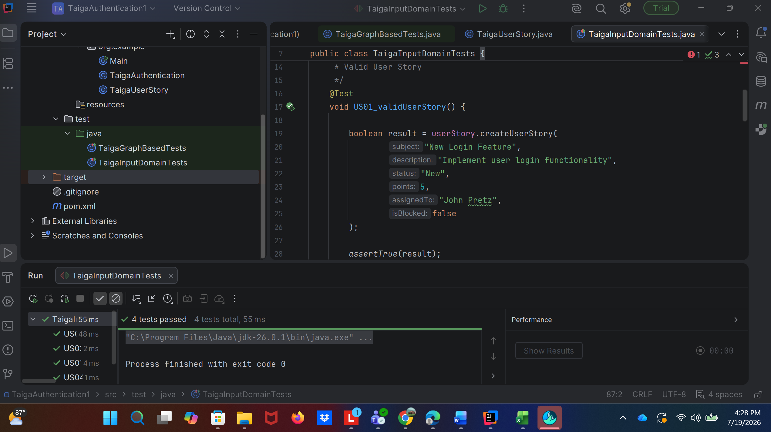The User Story input domain test cases were executed using JUnit 5 in IntelliJ IDEA. All four test cases passed successfully, and no defects were identified during execution. The implemented validation logic correctly handled valid inputs, required-field validation, invalid user assignments, and boundary-value validation for story points.
B.2 Task Test Cases Execution Results:
Test ID | Expected Result | Actual Result | Pass/Fail | Defect Found
TK-01 | The task is created successfully using valid input values. | Returned true, and the task was created successfully with a valid subject, user story relationship, assigned user, due date, and status. | Pass | No defect found
TK-02 | Task creation is rejected because the subject is required. | Returned false, and the task was rejected due to an empty subject. | Pass | No defect found
TK-03 | Task creation is rejected because the related user story and assigned user are invalid for project references. | Returned false, and the invalid user story relationship and assigned user were rejected. | Pass | No defect found
TK-04 | Task creation is rejected because the due date is invalid (in the past). | Returned false, and the task was rejected because the due date was earlier than the current date. | Pass | No defect found

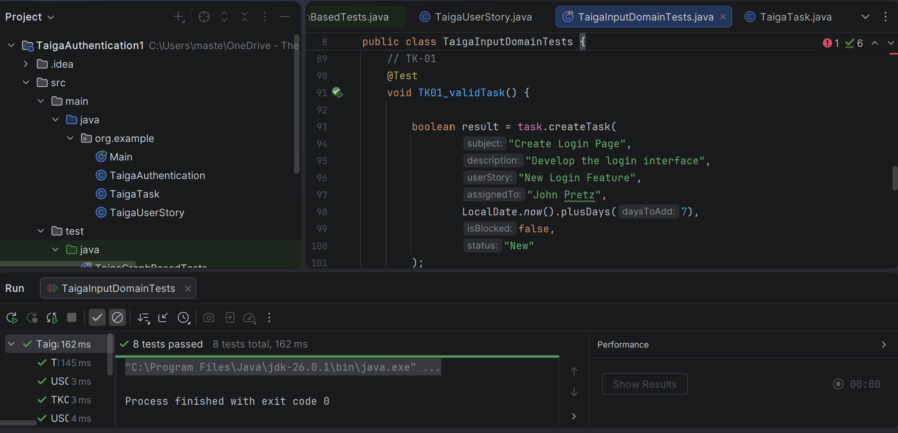All four Task test cases (TK-01 through TK-04) executed successfully and passed, confirming that the task creation functionality correctly handles valid inputs, empty subjects, invalid user story relationships, and invalid due dates according to the specified requirements.

B3. Issue Test Cases Execution Results:
Test ID | Expected Result | Actual Result | Pass/Fail | Defect Found
IS-01 | The issue is created successfully using valid input values. | Returned true, and the issue was created successfully with a valid subject, description, issue type, severity, priority, and assigned user. | Pass | No defect found
IS-02 | System rejects issue creation because the subject field is required and cannot be empty. | Returned false, and the issue was rejected because the subject field was left blank. | Pass | No defect found
IS-03 | System rejects issue creation because the issue type, severity, or priority contains an invalid value. | Returned false, and the invalid issue classification values were rejected by the system. | Pass | No defect found
IS-04 | System rejects issue creation because the assigned user or milestone/state relationship is invalid. | Returned false, and the invalid assigned user relationship was rejected by the system. | Pass | No defect fund

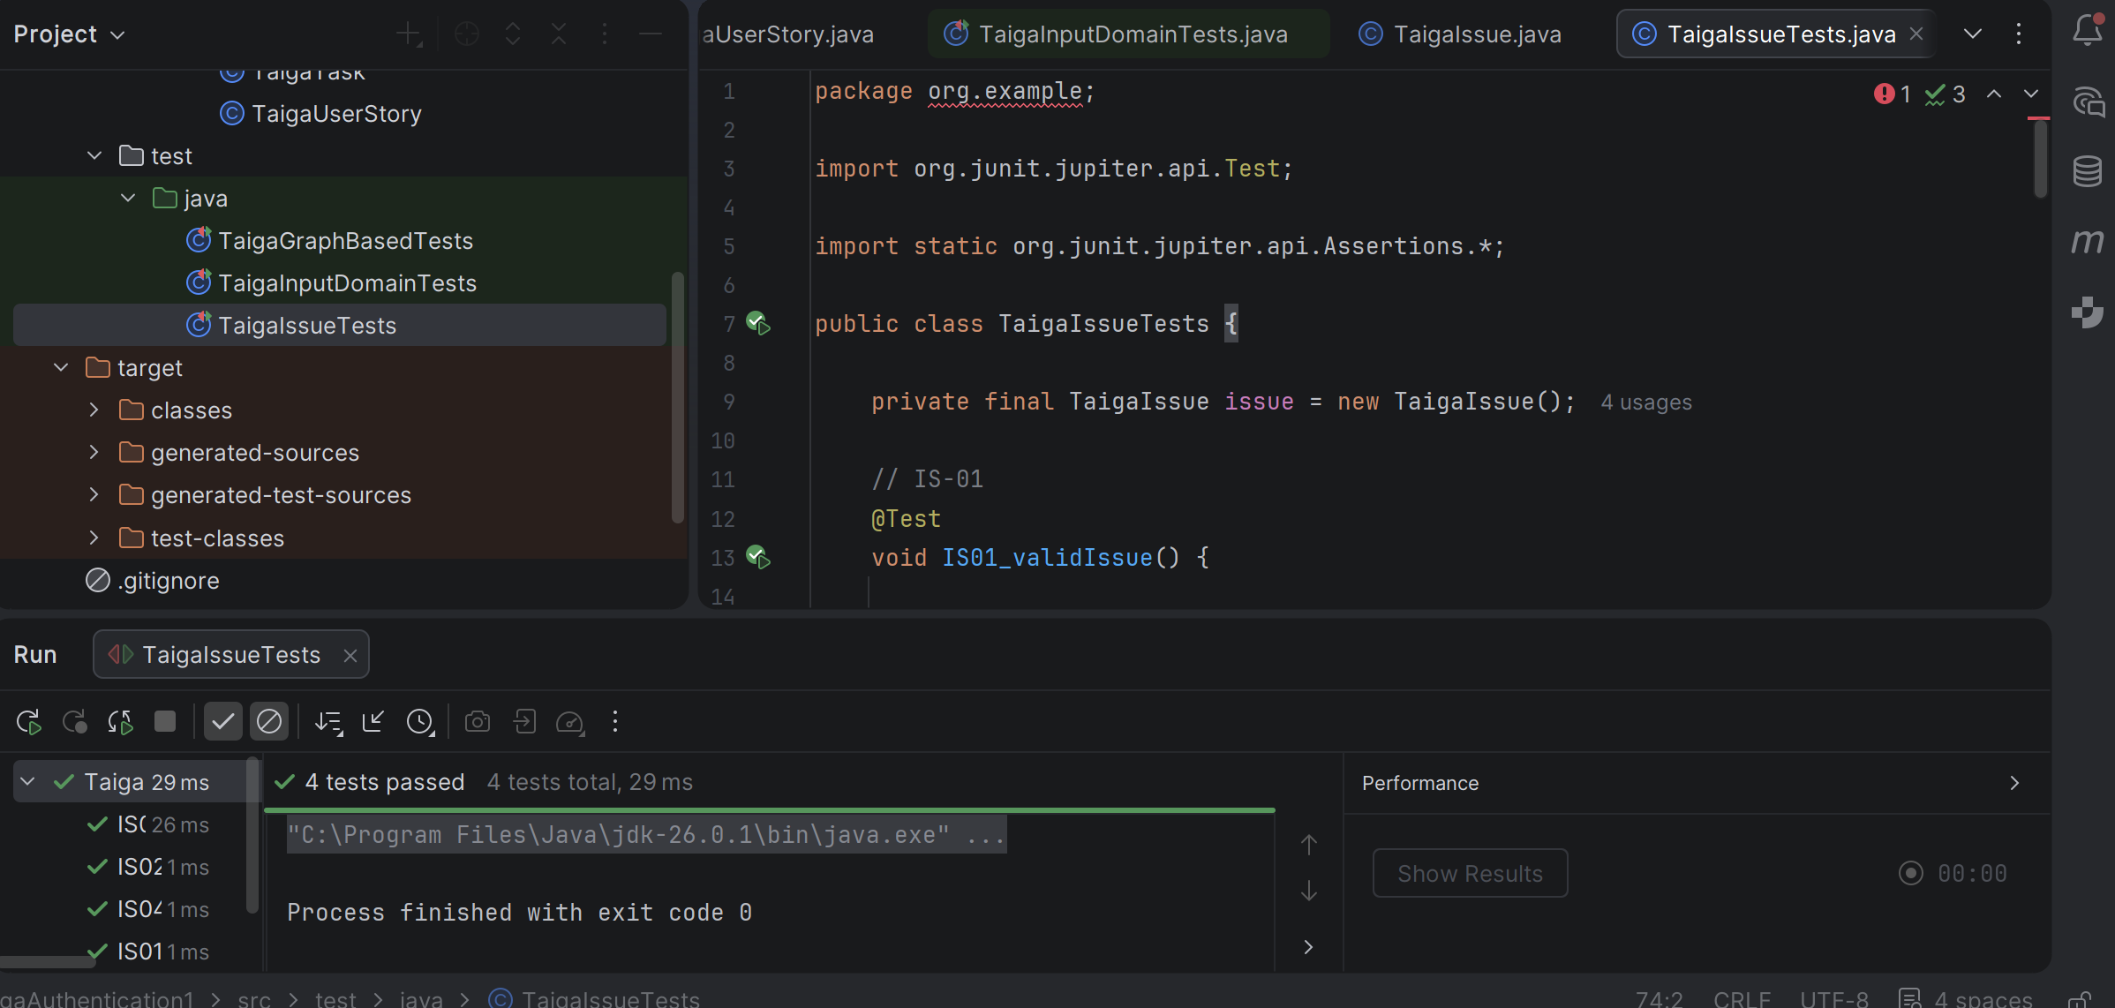All four Issue test cases (IS-01 through IS-04) passed successfully, demonstrating that issue creation functions correctly for valid inputs and appropriately rejects invalid subjects, classifications, and relationship/state values.

B.4 Sprit/Milestone Test Cases Execution Results:
Test ID | Expected Result | Actual Result | Pass/Fail | Defect Found
SP-01 | Sprint/Milestone is created successfully using valid input values. | Returned true, and the sprint was created successfully with a valid name, start date, finish date, and sprint state. | Pass | No defect found
SP-02 | System rejects sprint creation because the name is required. | Returned false, and the sprint was rejected because the name field was empty. | Pass | No defect found
SP-03 | System rejects sprint creation because the finish date occurs before the start date. | Returned false, and the sprint was rejected due to an invalid date range. | Pass | No defect found
SP-04 | System rejects sprint creation because the sprint state contains an invalid value. | Returned false, and the unsupported sprint state value was rejected. | Pass | No defect found

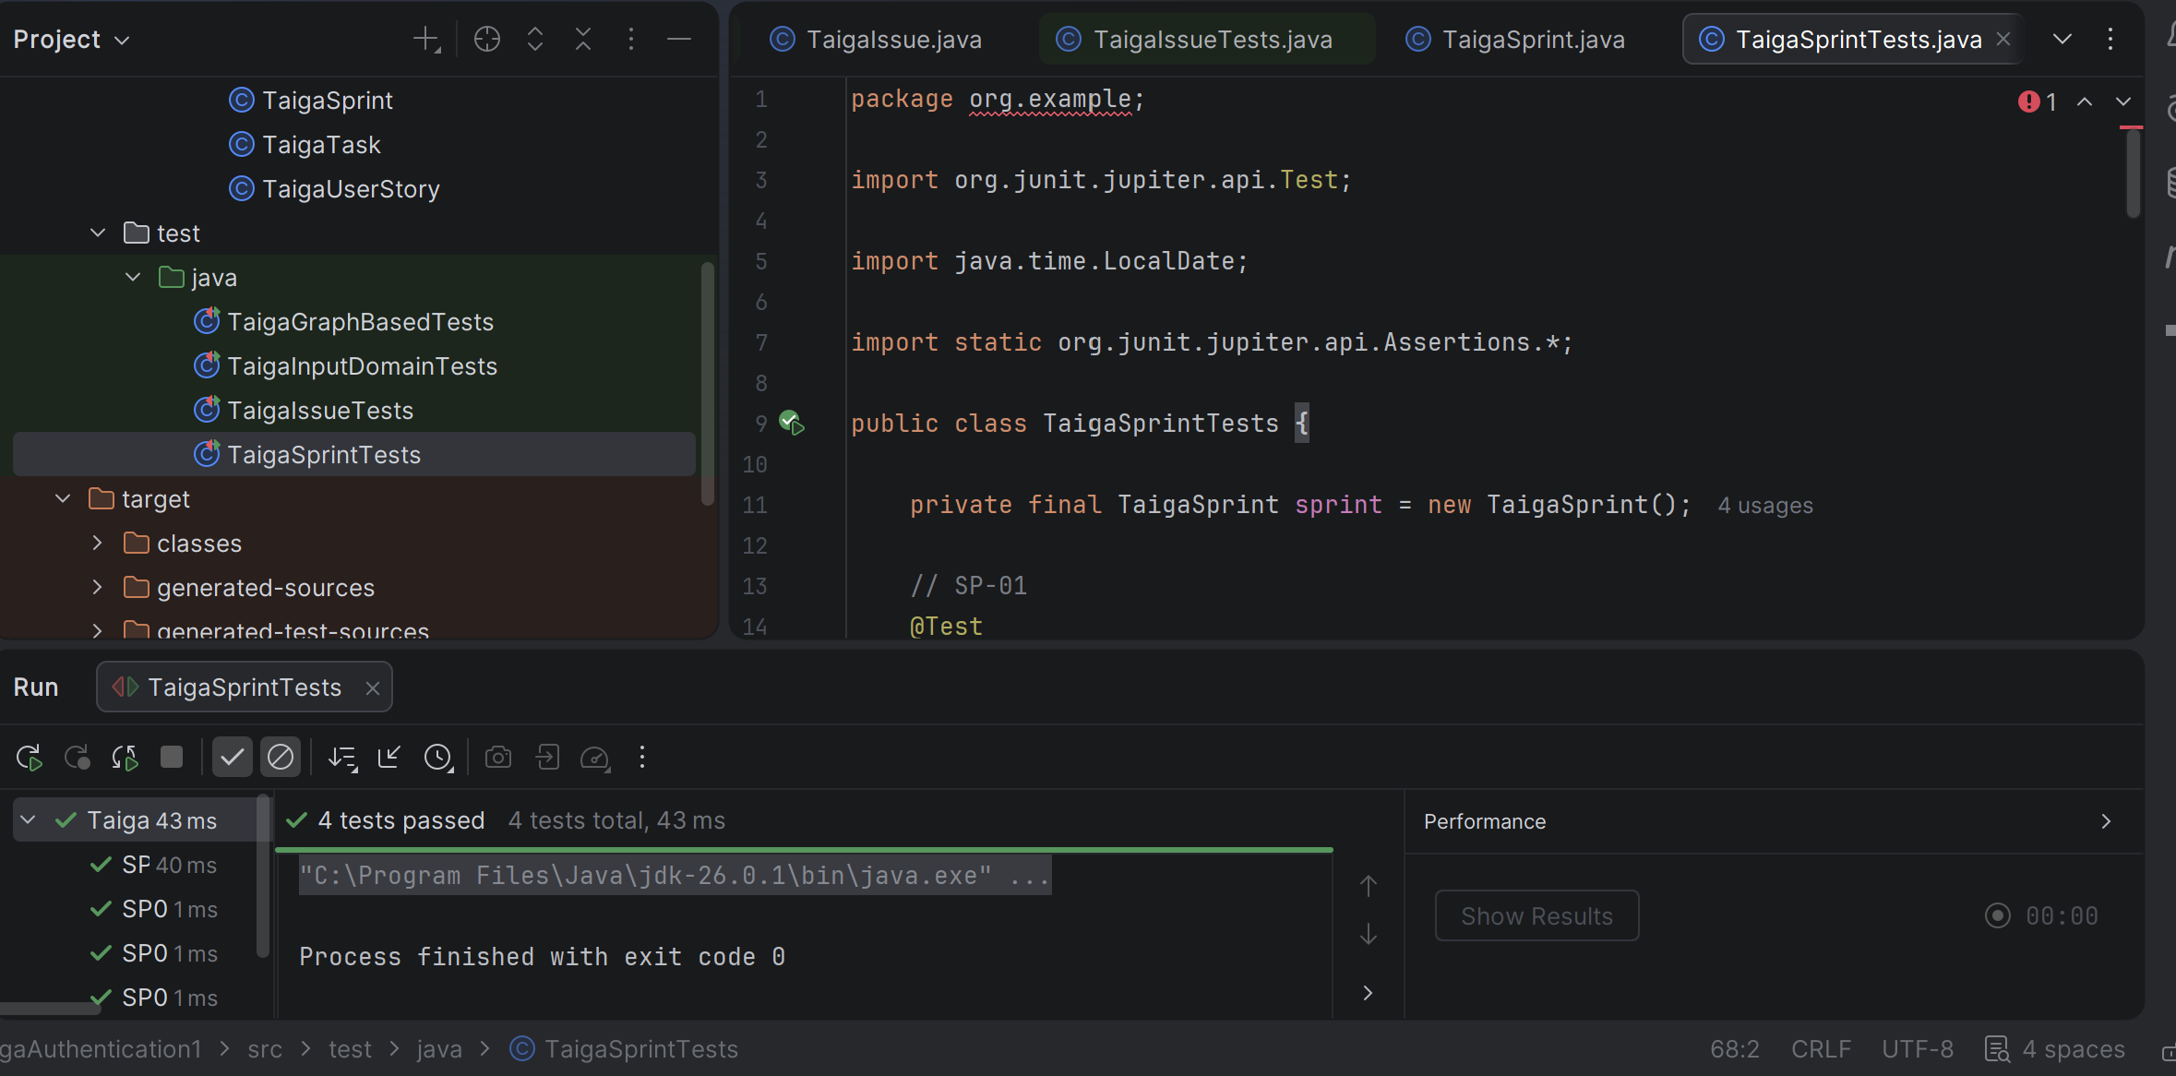All four Sprint/Milestone test cases (SP-01 through SP-04) passed successfully, verifying that sprint creation accepts valid input and correctly rejects missing required fields, invalid date ranges, and unsupported sprint state values.

B.5 User Registration/Login Test Cases Execution Results:
Test ID | Expected Result | Actual Result | Pass/Fail | Defect Found
AU-01 | User account is created successfully using valid registration data. | Returned true, and the user account was successfully created with a valid username, email, password, and full name. | Pass | No defect found
AU-02 | Registration is rejected because the username is invalid or already exists. | Returned false, and the registration request was rejected due to an invalid username. | Pass | No defect found
AU-03 | Registration is rejected because the email format is invalid or already exists. | Returned false, and the registration request was rejected due to an invalid email address. | Pass | No defect found
AU-04 | Registration is rejected because the password does not meet minimum requirements. | Returned false, and the registration request was rejected because the password was empty or invalid. | Pass | No defect found
AU-05 | The user is authenticated, and access is granted when valid login credentials are provided for an active account. | Returned true, and the user was successfully authenticated using valid credentials on an active account. | Pass | No defect found

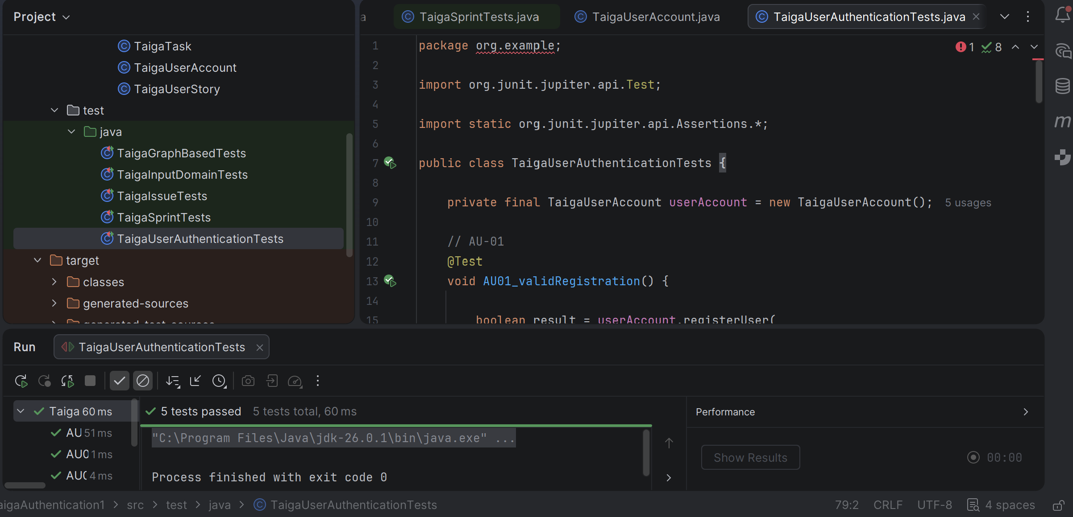All five Account/User Authentication test cases (AU-01 through AU-05) passed successfully, demonstrating that user registration and login functions correctly handle valid credentials and enforce username, email, password, and account-status validation rules.

